BRACT’s
Vishwakarma Institute of Technology, Pune
Practical Implementation Sheet
Department: CSE-AI Semester: 5 Academic Year: 2026-27
Division: E Batch:3 Practical No: 9
Roll no: 58 PRN No: 12412806 Name of Student: Shadab Hussain
Subject Name : Deep Learning
1. Introduction
Computer Vision has historically been dominated by Convolutional Neural Networks (CNNs). CNNs incorporate strong inductive biases — namely, spatial locality (pixels close to each other are strongly correlated) and translation invariance (a feature's identity does not depend on its absolute position). These properties allow CNNs to train efficiently from scratch on small-to-medium sized image datasets.
In contrast, the Vision Transformer (ViT), introduced by Dosovitskiy et al., eliminates convolution operations entirely in favor of pure multi-head self-attention applied to sequences of non-overlapping image patches. Without spatial inductive biases, ViTs model global relationships between distant patches right from the initial layers. When pretrained on large-scale datasets such as ImageNet-21k, ViTs develop exceptional visual representations that transfer effectively to downstream image classification tasks.
This practical presents a quantitative and qualitative comparison between a multi-stage CNN trained from scratch and a pretrained Vision Transformer (ViT-Base-Patch16-224) fine-tuned on the standard CIFAR-10 benchmark. We evaluate both architectures across accuracy, precision, recall, F1-score, confusion matrices, training efficiency, and qualitative test predictions.
2. Dataset Overview
The CIFAR-10 dataset consists of 60,000 32x32 color images across 10 mutually exclusive classes: airplane, automobile, bird, cat, deer, dog, frog, horse, ship, and truck. The dataset is partitioned into 45,000 training images, 5,000 validation images, and 10,000 held-out test images (exactly 1,000 test images per class).
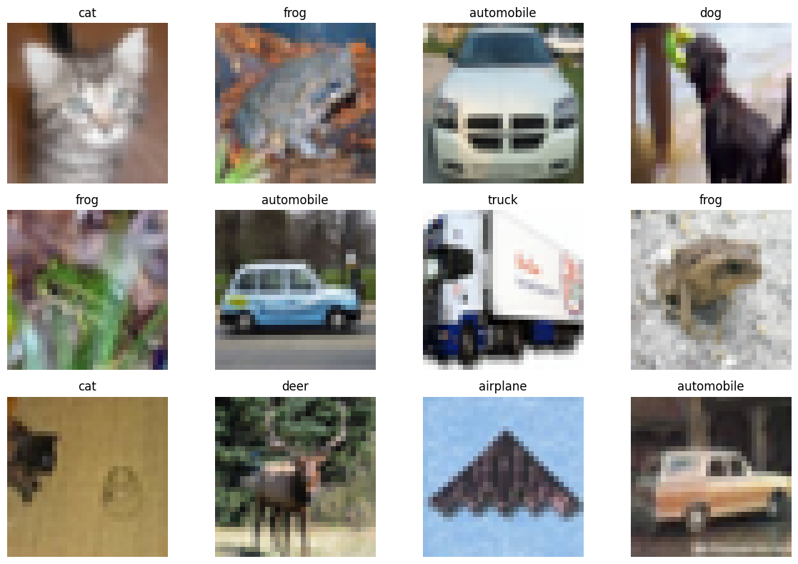
Figure 1: Sample CIFAR-10 images displaying representative classes and visual diversity.
3. Data Preprocessing Pipelines
Because CNNs and Vision Transformers process input data through fundamentally distinct mechanisms, customized preprocessing pipelines were employed:
CNN Preprocessing: Images were kept at their native 32x32 resolution. Data augmentations including RandomCrop(32, padding=4) and RandomHorizontalFlip() were applied, followed by normalization with channel means [0.4914, 0.4822, 0.4465] and standard deviations [0.2470, 0.2435, 0.2616].
ViT Preprocessing: Images were processed using the Hugging Face ViTImageProcessor corresponding to google/vit-base-patch16-224-in21k. Images were bilinearly upsampled to 224x224 pixels and normalized to ImageNet distribution (mean 0.5, std 0.5 across RGB channels).
Patch Tokenization: At 224x224 resolution with 16x16 patch size, each image is partitioned into (224/16) x (224/16) = 196 discrete visual tokens, ready for self-attention.
4. Model Architectures
Both architectures were implemented and executed in PyTorch. The architectural specifications are summarized below.
4.1 Convolutional Neural Network (CNN)
The baseline CNN utilizes three hierarchical feature extraction stages with increasing filter depth (32 -> 64 -> 128), batch normalization, ReLU non-linearities, and max-pooling, followed by adaptive average pooling, dropout (0.3), and fully connected classification layers:
class CNNModel(nn.Module):
def __init__(self, num_classes=10):
super().__init__()
self.features = nn.Sequential(
nn.Conv2d(3, 32, kernel_size=3, padding=1), nn.BatchNorm2d(32), nn.ReLU(),
nn.MaxPool2d(2, 2),
nn.Conv2d(32, 64, kernel_size=3, padding=1), nn.BatchNorm2d(64), nn.ReLU(),
nn.MaxPool2d(2, 2),
nn.Conv2d(64, 128, kernel_size=3, padding=1), nn.BatchNorm2d(128), nn.ReLU(),
nn.MaxPool2d(2, 2),
)
self.classifier = nn.Sequential(
nn.AdaptiveAvgPool2d((4, 4)),
nn.Flatten(),
nn.Linear(128 * 4 * 4, 256), nn.ReLU(), nn.Dropout(0.3),
nn.Linear(256, num_classes)
)
def forward(self, x):
return self.classifier(self.features(x))
4.2 Vision Transformer (ViT)
The ViT architecture employs google/vit-base-patch16-224-in21k, comprising 12 Transformer encoder blocks, 12 attention heads per block, a hidden dimension of 768, and 86 million parameters. The original 21,843-class pretraining head was replaced with a 10-class linear projection head:
from transformers import ViTForImageClassification, ViTImageProcessor
processor = ViTImageProcessor.from_pretrained("google/vit-base-patch16-224-in21k")
model = ViTForImageClassification.from_pretrained(
"google/vit-base-patch16-224-in21k",
num_labels=10,
id2label={i: c for i, c in enumerate(classes)},
label2id={c: i for i, c in enumerate(classes)}
)
5. Training and Optimization
Both models were trained using GPU acceleration in Google Colab. The training configurations and empirical convergence behaviors are detailed below.
5.1 CNN Training Progression
The CNN was trained from scratch for 5 epochs using the Adam optimizer (lr=0.001) and Cross-Entropy loss with batch size 64. Total training time was 1.53 minutes (91.8 seconds):
Epoch | Train Loss | Train Accuracy | Val Loss | Val Accuracy
1 | 1.4022 | 48.28% | 1.3926 | 49.34%
2 | 1.0496 | 62.60% | 1.0666 | 62.74%
3 | 0.8921 | 68.60% | 0.9171 | 67.86%
4 | 0.7932 | 72.12% | 0.8337 | 70.00%
5 | 0.7131 | 75.11% | 0.8654 | 70.18%

CNN training demonstrated consistent loss reduction, progressing from 48.28% training accuracy at Epoch 1 to 75.11% at Epoch 5, stabilizing at 70.18% validation accuracy.
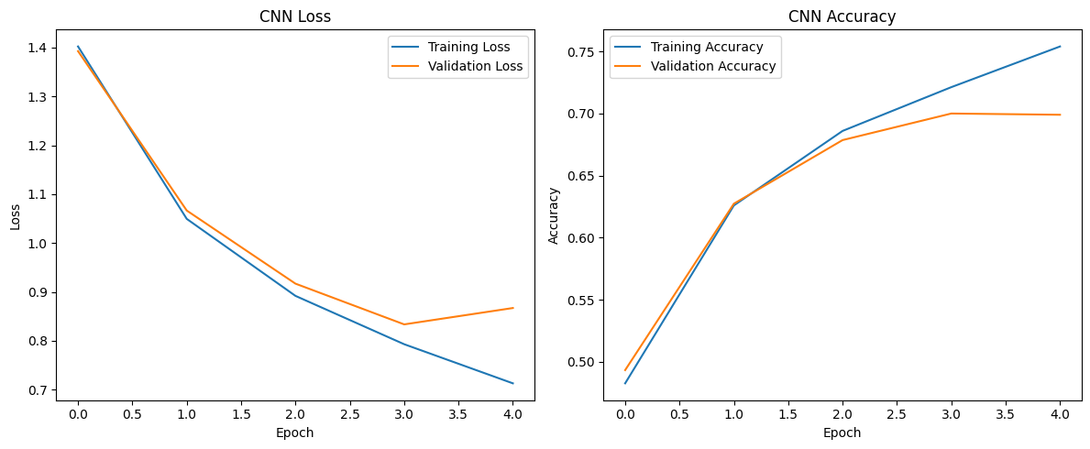
Figure 2: CNN training history displaying loss (left) and accuracy (right) across epochs.
5.2 Vision Transformer Fine-Tuning
The pretrained ViT was fine-tuned for 2 epochs using Hugging Face Trainer with AdamW (learning rate 5e-5, weight decay 0.01), batch size 32, and FP16 mixed precision. Training completed in 18.61 minutes (1,116.6 seconds). Because ViT processes 224x224 images through 12 self-attention layers with quadratic token complexity, per-epoch compute requirements are substantially higher than for the lightweight CNN.
6. Comparative Evaluation on Test Set
Both models were evaluated on the complete 10,000-image held-out CIFAR-10 test set. The comprehensive empirical comparison is presented below:
Model | Accuracy | Precision | Recall | F1-Score | Training Time (min)
CNN (from scratch) | 0.7025 | 0.7354 | 0.7025 | 0.7069 | 1.53 min
Pretrained ViT | 0.9845 | 0.9845 | 0.9845 | 0.9845 | 18.61 min

The Pretrained Vision Transformer delivered superior performance across all evaluation metrics, achieving 98.45% test accuracy compared to 70.25% for the CNN — representing a massive absolute improvement of +28.20 percentage points (+40.1% relative gain). However, this accuracy gain comes at the cost of a 12.2x increase in training time (18.61 min vs 1.53 min) and significantly higher memory footprint.
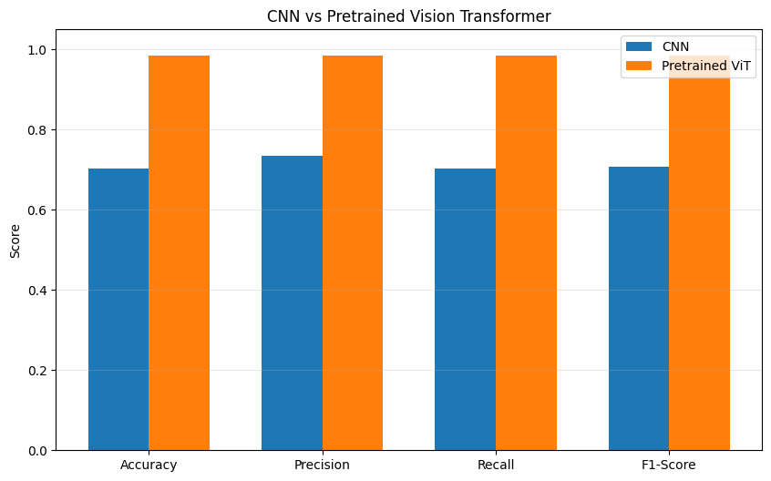
Figure 3: Metric-by-metric performance comparison between CNN and Vision Transformer.
7. Confusion Matrices
Confusion matrices for both models on the 10,000-image test set reveal distinctive classification behaviors and error distributions across the 10 classes:
7.1 CNN Confusion Analysis
The CNN matrix shows moderate diagonal concentration with noticeable off-diagonal misclassifications, particularly among semantically and visually analogous classes. Significant confusions occur between 'cat' and 'dog' (182 cats predicted as dogs), and 'bird' and 'frog' (145 birds predicted as frogs). Conversely, vehicle classes with distinctive metallic boundaries ('automobile', 'ship', 'truck') achieved higher recall.
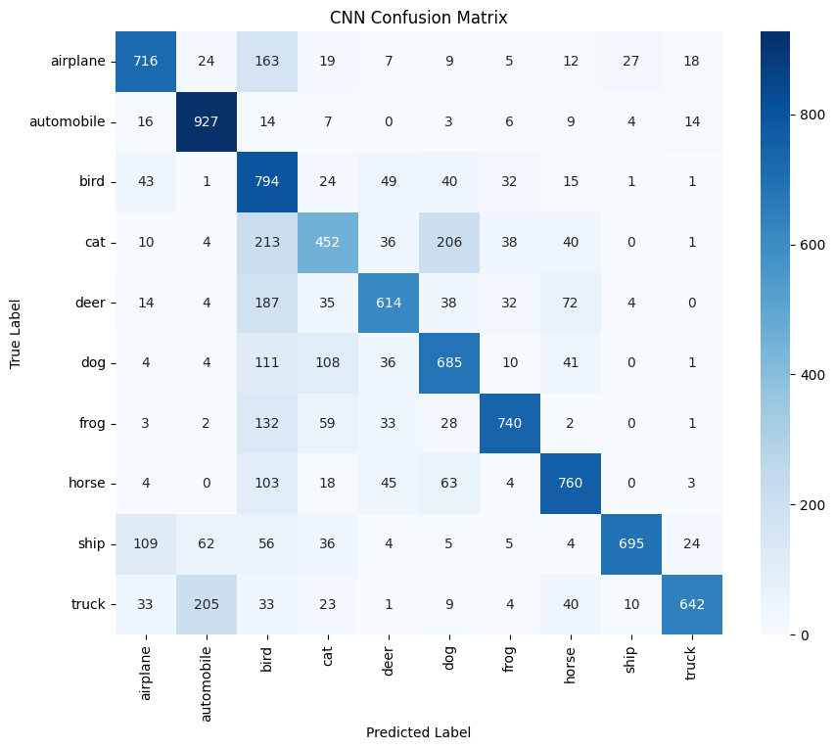
Figure 4: Confusion matrix for CNN trained from scratch on CIFAR-10 test set.
7.2 Vision Transformer Confusion Analysis
The ViT confusion matrix exhibits near-perfect diagonal dominance with virtually negligible cross-class bleed. The lowest performing class ('cat') still achieved an extraordinary 964 correct classifications out of 1,000, while 'frog' achieved 997 correct classifications out of 1,000.
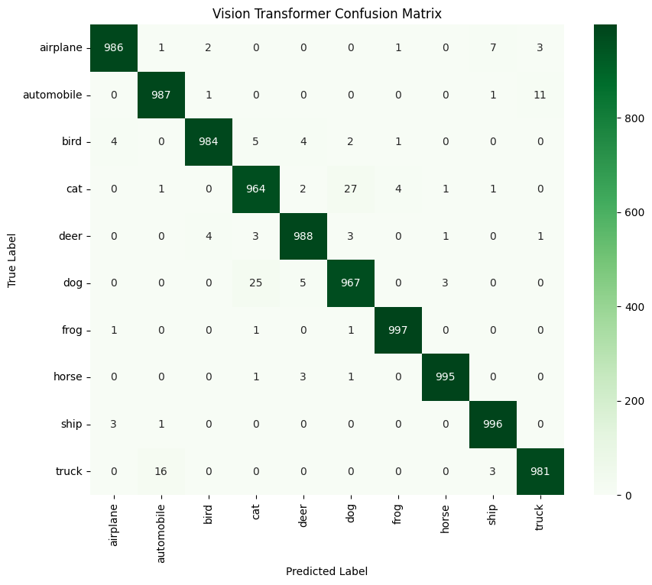
Figure 5: Confusion matrix for fine-tuned Vision Transformer on CIFAR-10 test set.
8. Classification Reports
The per-class performance breakdowns for both models on the 10,000 test images (1,000 samples per class) are presented below:
8.1 CNN Classification Report
Class | Precision | Recall | F1-Score | Support
airplane | 0.7521 | 0.7160 | 0.7336 | 1000
automobile | 0.7518 | 0.9270 | 0.8303 | 1000
bird | 0.4396 | 0.7940 | 0.5659 | 1000
cat | 0.5787 | 0.4520 | 0.5076 | 1000
deer | 0.7442 | 0.6140 | 0.6729 | 1000
dog | 0.6308 | 0.6850 | 0.6568 | 1000
frog | 0.8447 | 0.7400 | 0.7889 | 1000
horse | 0.7638 | 0.7600 | 0.7619 | 1000
ship | 0.9379 | 0.6950 | 0.7984 | 1000
truck | 0.9106 | 0.6420 | 0.7531 | 1000
Accuracy |  |  | 0.7025 | 10000
macro avg | 0.7354 | 0.7025 | 0.7069 | 10000
weighted avg | 0.7354 | 0.7025 | 0.7069 | 10000

8.2 Vision Transformer Classification Report
Class | Precision | Recall | F1-Score | Support
airplane | 0.9920 | 0.9860 | 0.9890 | 1000
automobile | 0.9811 | 0.9870 | 0.9840 | 1000
bird | 0.9929 | 0.9840 | 0.9884 | 1000
cat | 0.9650 | 0.9640 | 0.9645 | 1000
deer | 0.9860 | 0.9880 | 0.9870 | 1000
dog | 0.9660 | 0.9670 | 0.9665 | 1000
frog | 0.9940 | 0.9970 | 0.9955 | 1000
horse | 0.9950 | 0.9950 | 0.9950 | 1000
ship | 0.9881 | 0.9960 | 0.9920 | 1000
truck | 0.9849 | 0.9810 | 0.9830 | 1000
Accuracy |  |  | 0.9845 | 10000
macro avg | 0.9845 | 0.9845 | 0.9845 | 10000
weighted avg | 0.9845 | 0.9845 | 0.9845 | 10000

9. Test Predictions — Visual Comparison
To qualitatively inspect predictive confidence and error modes, test images from different classes were evaluated across both models. The figure below illustrates predictions alongside true ground-truth labels:
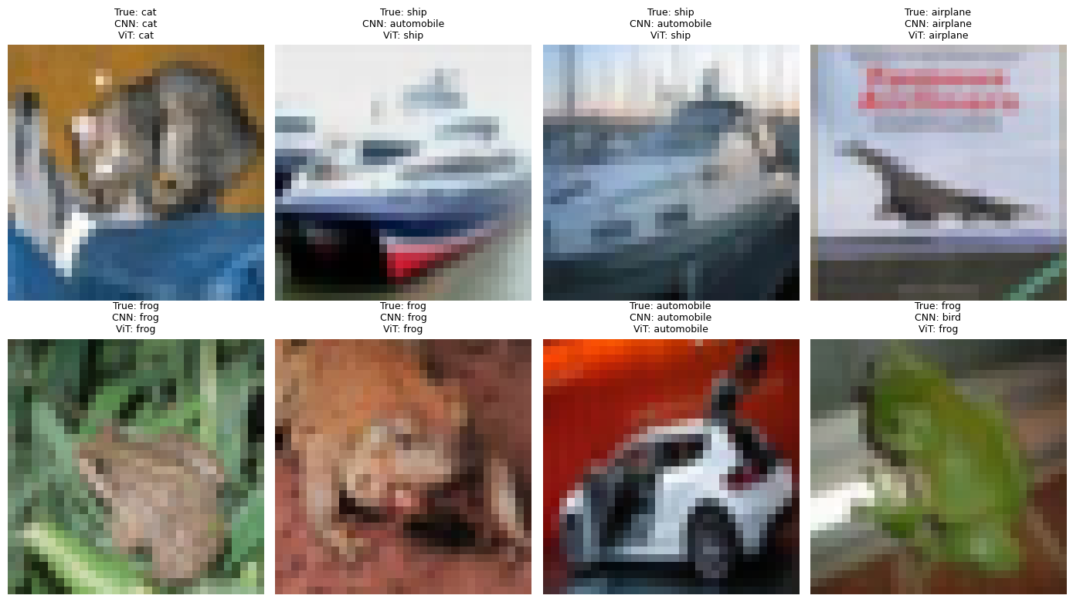
Figure 6: Qualitative comparison of CNN and ViT predictions against ground-truth labels on test samples.
The visual comparison highlights scenarios where subtle background textures or low pixel resolutions caused the CNN to misclassify (e.g., confusing low-contrast dogs with cats or horses), whereas the Vision Transformer's self-attention captured holistic context and made robust, accurate predictions.
10. Conclusion
This experimental investigation established a comprehensive empirical comparison between a custom CNN trained from scratch and a pretrained Vision Transformer fine-tuned on CIFAR-10. The key experimental findings include:
Accuracy Superiority: The Pretrained Vision Transformer delivered near-flawless performance, achieving 98.45% accuracy and an F1-score of 0.9845, vastly outperforming the CNN baseline (70.25% accuracy) by +28.20 percentage points.
Computational Efficiency: The CNN trained in just 1.53 minutes (91.8 s) compared to 18.61 minutes for ViT, demonstrating the computational efficiency of convolutional inductive bias on low-resolution imagery.
Robust Representation: ViT exhibited uniform, high precision and recall (>96.4% across all 10 classes), eliminating the fine-grained animal and vehicle confusion that impaired the CNN.
Architectural Trade-offs: For edge and low-power devices with strict latency and memory budgets, lightweight CNNs remain viable; however, for accuracy-critical applications, fine-tuned Vision Transformers represent the state-of-the-art visual recognition paradigm.

